Lab 5: Responsive Webpages
Name: Yem Phalpichkiri
Class: M2
- Responsive Top Navigation

In desktop View
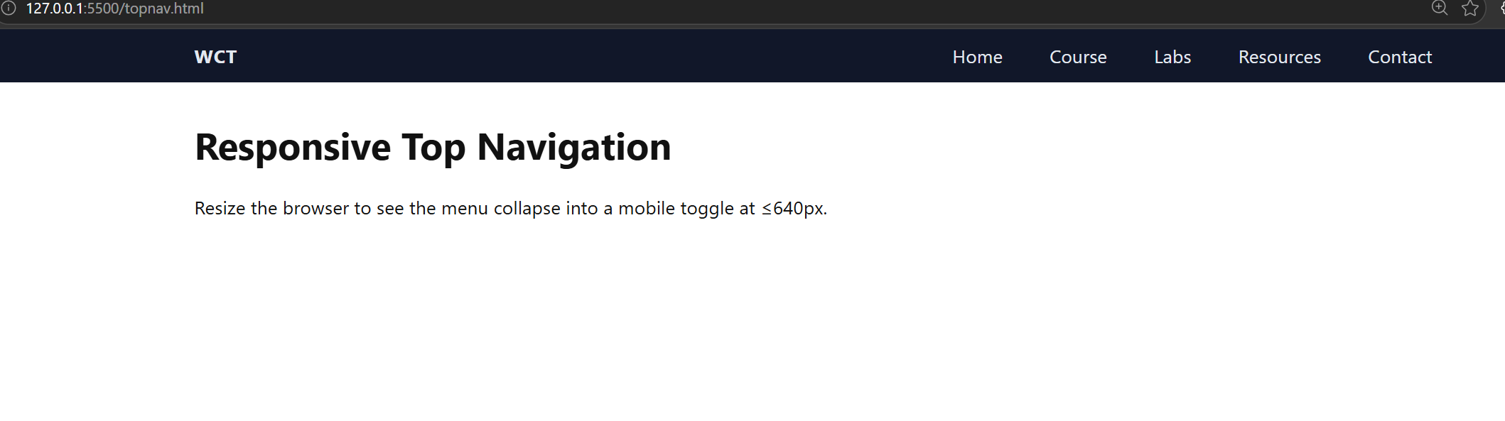In mobile view
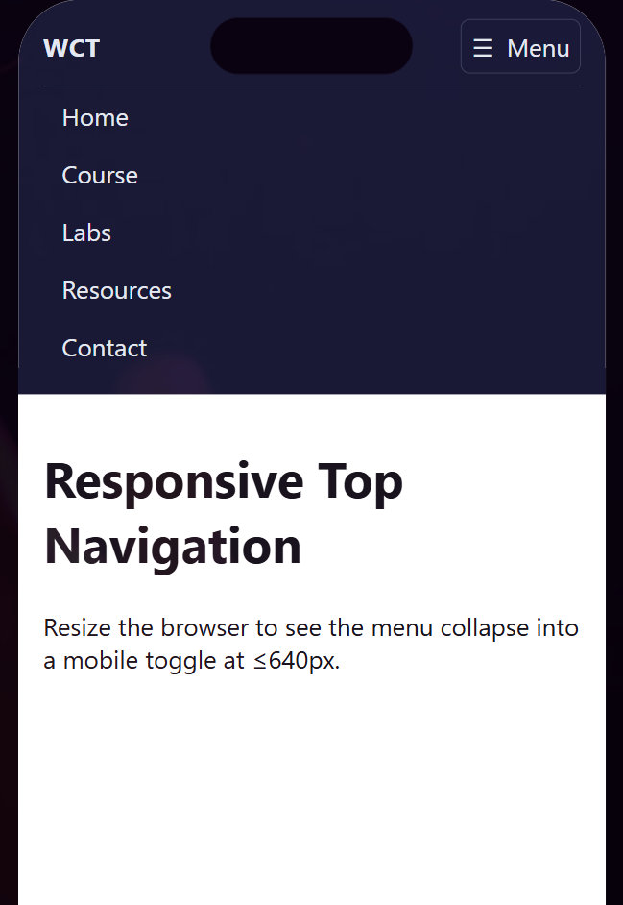
- Layout

In desktop view
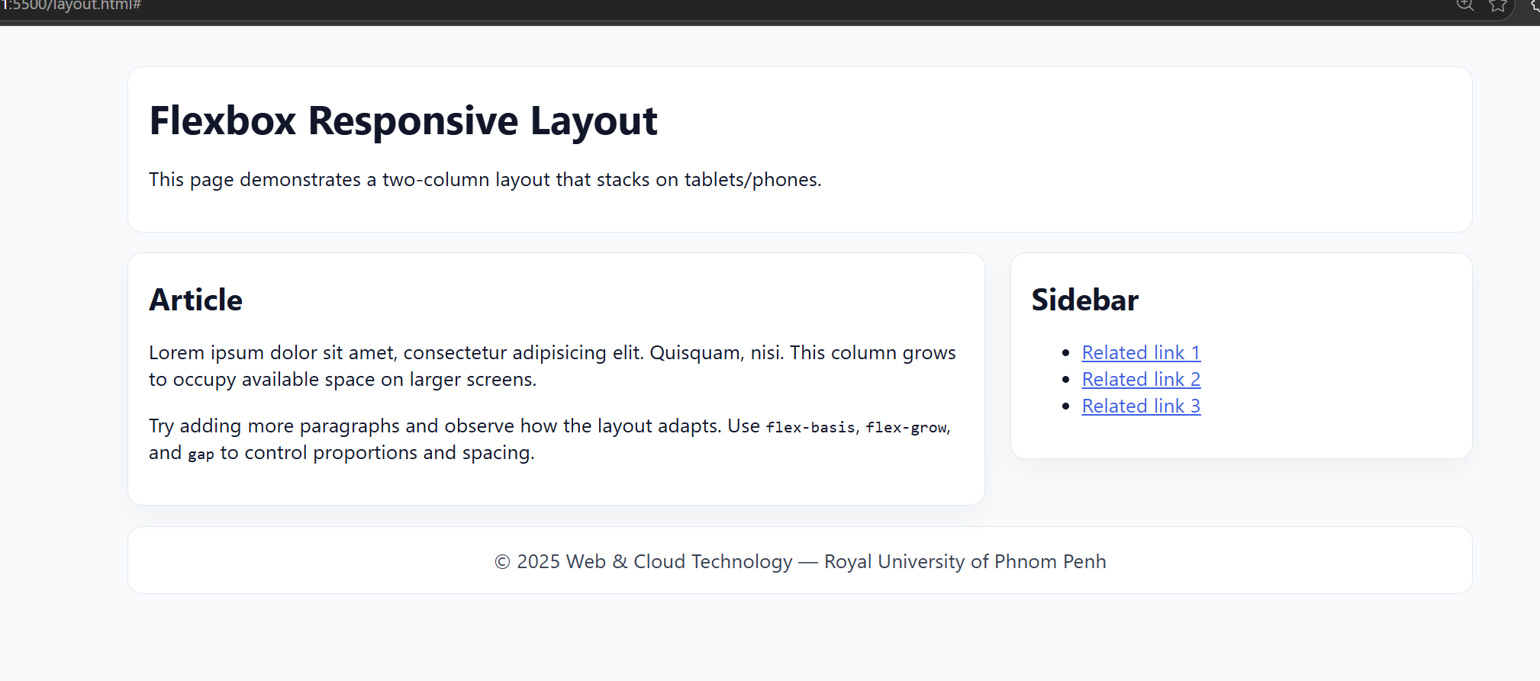
In mobile view
